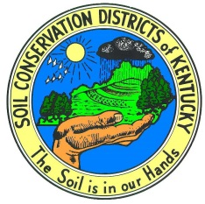
Woodford County Conservation District
2016-2017 Teacher Donation Application
Due March 15th

Request can be made for anything conservation/environment related, up to $500 per application. Examples of requests (not limited to); registration for school event, environmental day,
materials, material for project, etc.

Please make note that the conservation district will not be dispersing funds to you or the school district.
Items requested will be filled by the district and then donated to you and your classroom. Give as much information as needed for us to purchase or pay for whatever you are requesting.
Application #: __________________
Teacher(s) _______________________________________
School/Classroom/Grade _______________________________________
Number of students: _______________________________________
Donation Request Summary (Please include what, when, where, why): ________________________________________________________________________________________________________________________________________________________________________________________________________________________________________________________________________________________________________________________________________________________________________________________________________________________________________________________________________________________________________________________________________________________________________________________________________________________________________________________________________________________________________________________________________________________________________________________________________________________________________________________________________

Items Requested:
Quantity | Item Description | Company | Stock # | Cost/Item | Total
How does this project directly relate to natural resources conservation education? ___________________________________________________________________________________________________________________________________________________________________________________________________________________________________________________________________________
____ My students and I will participate in the annual WCCD sponsored Conservation Art/Writing Contests.
____ I understand that a project follow up is required.
____ I am willing to present my project at future workshops/meetings to promote conservation district programs.
____ I will try to attend at least 2 WCCD sponsored events throughout the year. (Spring Fling, Farm Tour, Teacher Workshop, etc.)
_______________ _______________________________ Date Signature
*If more space is needed feel free to type up application on your own, please use this format, and answer all questions.
Signature: __________________________ Approval Date: ____________________
Application #: _______________________

